1. basic picture and control panel:

operating panel
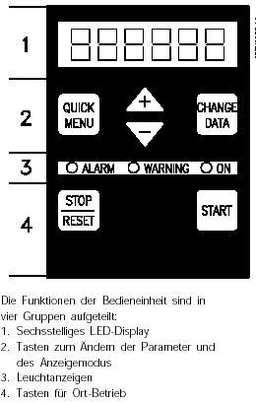

The functions of the control unit are
divided in four groups:
- six-digit LED display
- buttons for changing the parameters
and the indicator mode
- signal lamps
- buttons for hand operating

2. indicate:

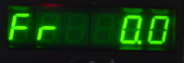
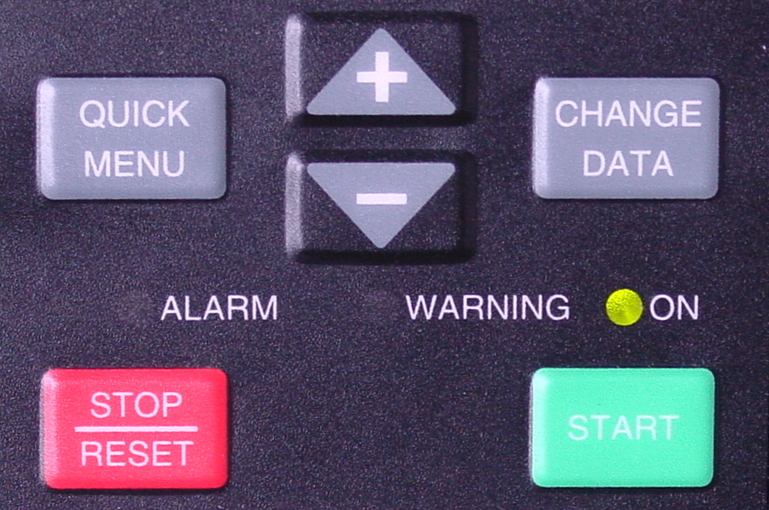
basic picture

High-speed menu mode
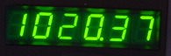

complete parameters
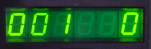

3. operation:

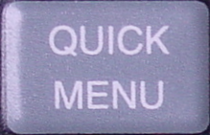
- through press the button you arrives into the high-speed menu mode
see fig.1

- through simultaneous pressing
these both buttons

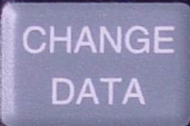
and 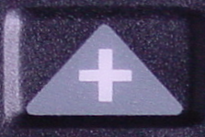 you have entrance to all parameters
see fig.2

- to change parameters press this button
- always confirm after change of a value with this button

fig.1
fig.2

